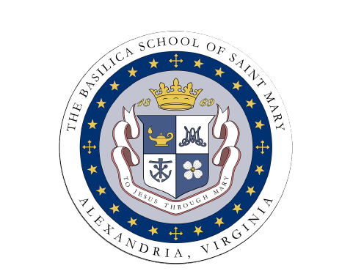
October Meeting of the Board
Meeting Minutes – Annotated
The Basilica School of Saint Mary Home and School Association
Wednesday, October 12 at 7:00 PM
BSSM Teacher’s Lounge
A full version of the meeting minutes is available upon request by emailing hsa@smsva.org.

- 7:14 p.m.: Call to Order – Kristen Zottola, HSA President
- Opening Prayer and Pastor’s Report – Fr. Hathaway
  - Students returned to mass in the Basilica and to confessions.
  - Saint Parade coming up.
  - Construction update.
- Principal’s Report/Faculty Report – Mr. Robert Loia, Principal
  - Construction update.
  - Listening sessions: eager for return to normalcy, desire for the return of the arts. Saintly Families will be coming back.
  - Uniforms: representation of the school
  - Formation on Boys.
  - Technology: Committee looking at how to incorporate technology into the regular classroom, starting with typing.
  - High School Information Night
  - MAP Testing: Parents will have information by November 8.
  - Guidance Curriculum: report coming home soon.
  - Q&A:
    - MAP Testing
    - Formation on Boys
    - Parent Teacher Conferences – in person or zoom
    - Parental involvement in the classroom/volunteering
    - Schoology – purpose, usefulness, challenges, development
- Faculty Report – No Report for October, Representative TBD
- Treasurer’s Report – Sarah Lyle, HSA Treasurer
  - Solvent, with surplus.
  - Parent-Teacher Social, luncheons, etc.
- Secretary’s Report – Erica Dempsey, HSA Secretary
  - Next meeting November 16.
  - Agenda items by November 10.
- Mary Lead Us Campaign/Annual Fund Report – Anne Mathis/Jonathan Day
  - Annual Fund: At $9,280. Mailers, phone-o-thon, reflection series. Event in the spring with Rudy’s Golf.
  - Mary Lead Us Campaign: Raised a total of $10.3 million from 900 donors. $522,000 for the establishment of the Mater Dei program. More new naming opportunities. Beam signing for students and faculty.
- Hospitality Committee Update – Cara Burke, Stephanie Scott, Rebecca Stalnaker
  - Teachers luncheons, First Friday Bagels, Parent-Teacher Social. November will be a busy month.
- FIS/Room Parent Update – Stephanie Dolan/Laura Coleman
  - Will work to get parents in for lunches and recesses. Need to ensure that volunteers are certified.
  - Slate of extracurricular activities that require volunteers – Battle of the Books, Odyssey of the Mind, Corporal Works of Mercy.
  - Will be marketing specific roles in The Messenger.
  - Room Parents are all assigned. Schoology is presenting some challenges. Some classes have had better successes.
- External Fundraising and Community Outreach – Jen Szymanski, Jocelyn Voell
  - Confirmed dinners for The Italian Place and for Lebanese Taverna.
  - Brainstorming ideas for Community Outreach related to health, healthy living, healthy choices. Looking ahead at Earth Day activities and whole family health activities.
  - Should look for ways to address mental health concerns.
- CYO Update – Jean Marie O’Neil
  - Track: had about 90 kids participate.
  - Cross Country: About 80-90 kids participated.
  - Tennis: 180 kids participated.
  - Basketball: 280 kids registered. Uniforms have been ordered. All coaches will participate in the Play Like a Champion program.
  - CYO Mass on October 16 at 11:30 a.m.
  - Bringing back end of season banquets.
  - Charitable activities (sneaker donations, SockTober, Hoops for Hunger)
- Special Events – Sherwood Turnbull
  - Auction will be in the gym on February 11, with a Mardi Gras theme.
  - Raised over $180,000 last year; hope to do the auction concurrently with the virtual auction.
- New Business
  - Curriculum for Social and Emotional Learning (will be made available).
  - FIS Hours (will be assigned soon)
- 9:00 p.m.: Adjournment – Kristen Zottola, HSA President

